1. Ng new PROJECT
2. Npm install –save bootstrap 🡸 would install the latest version.
   1. Inform the CLI that Bootstrap should be included in our final bundle it creates as CLI bundles all the script and styles files.
   2. 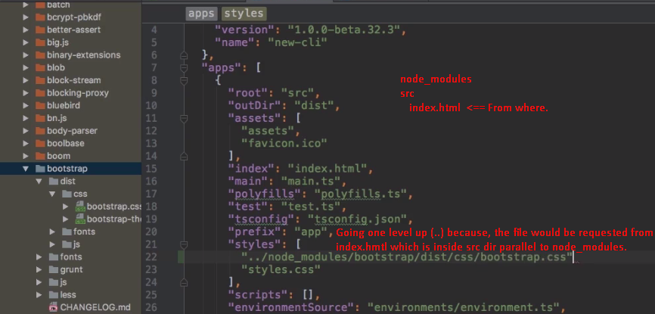
3. 